CENSUS DUTY MANAGEMENT SYSTEM

Group-members

|  |  |
| --- | --- |
| YADDALA PAVAN KUMAR REDDY | AM.EN.U4CSE20175 |
| Nukala Aashish Gopal | AM.EN.U4CSE20148 |
| SIRUGUPPA VISHNU SAI KAUSHAL | AM.EN.U4CSE20164 |
| Thupakula. Siddartha | AM.EN.U4CSE20170 |

**Abstract :**

* What is Census ?
  + An official count or survey, especially of a population.
  + A census is the procedure of systematically calculating, acquiring and recording information about the members of a given population.

This project aims to develop a Censes duty management system. Teachers are assigned with the particular locations. They have to visit the houses in the particular location and the teacher has to collect the details of the members in the house. This system allows teachers to enter the details of the house members and also allows the user to update the details of the house members.

Teachers should login to system for adding the details. Users can get login to the system by using their Aadhaar Number and date of birth (same as in Aadhaar). By using the Aadhaar number as User-Id and date of birth as Password.

**Functional requirements of the system :**

**Admin :**

* + Admin Login o Add Teachers
  + Manage Teachers
  + Assign locations to Teacher

**Teacher :**

* + Teacher Login o Adds Details of Family members **User (Family Head) :**
  + User Login
  + Updates Family Member Details (like name, dob, sex, email, phone,

Education,Occupation, Address, Area, City, State, Aadhar card number, caste). o View status

**Use cases :**

* Login
* Add Teachers
* Assign Locations to Teachers
* Validate House member details
* Add House member details
* View assigned locations by admin
* View status
* Update House member details
* Logout

**Actors :**

* Admin(Head) - Assigns locations to teachers
* Teachers - visit the houses at particular location assigned by admin and records the details of house members.
* User - Owner of the house who can update their details

**Use Case description :**

|  |  |
| --- | --- |
| Use Case : | Login |
| Actor : | Admin, Teacher, User |
| Inputs : | User-ID, Password |
| Outputs : | Verify the inputs.  If the credentials are wrong error message will be displayed. |
| Description : | If correct credentials are entered then the actors can access the data accordingly . |

|  |  |
| --- | --- |
| Use Case : | Add Teachers |
| Actor : | Admin |
| Description : | Since Admin is the head he (or) she will add the details of teachers to the data. |

|  |  |
| --- | --- |
| Use Case : | Assign Location to teachers |
| Actor : | Admin |
| Description : | Since Admin is the head he (or) she will assign particular location for each teacher. In a way that no two teachers are assigned for same location. |

|  |  |
| --- | --- |
| Use Case : | Validate House member details |
| Actor : | Admin |
| Description : | Since Admin is the head he (or) she will verify the details of the house members gathered by teachers. |

|  |  |
| --- | --- |
| Use Case : | View locations assigned by the admin |
| Actor : | Teacher |
| Description : | Teacher will view the location assigned by the admin. So that the teacher can visit the houses assigned in the particular location. |

|  |  |
| --- | --- |
| Use Case : | Add house member details |
| Actor : | Teacher |
| Description : | Teacher will visit the houses assigned in the particular location and gather the details of house members and record the data. |

|  |  |
| --- | --- |
| Use Case : | Update house member details |
| Actor : | User |
| Description : | User can the update the details of the house members. |

|  |  |
| --- | --- |
| Use Case : | View status |
| Actor : | User |
| Description : | User can view the status of the given house member details. |

|  |  |
| --- | --- |
| Use Case: | Logout |
| Actor: | Admin, Teacher, User |
| Description: | They can logout from the system |

**USECASE DIGRAM:**

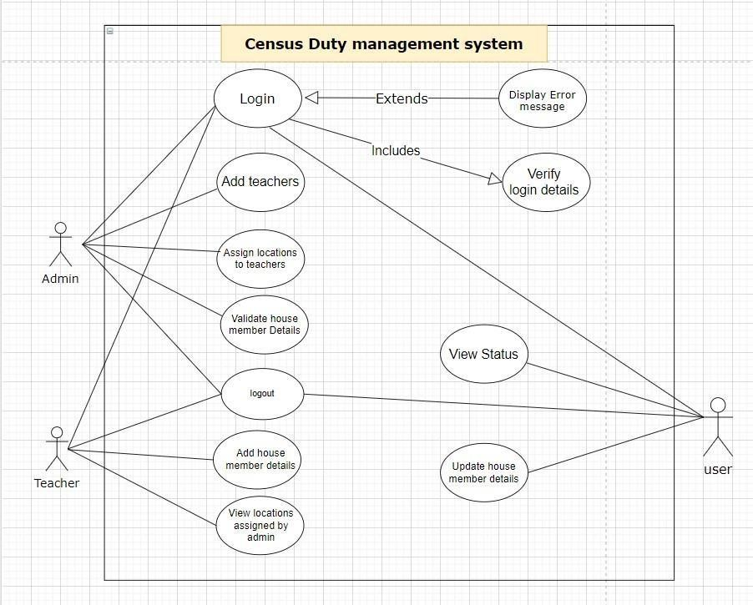

**User interface design :**

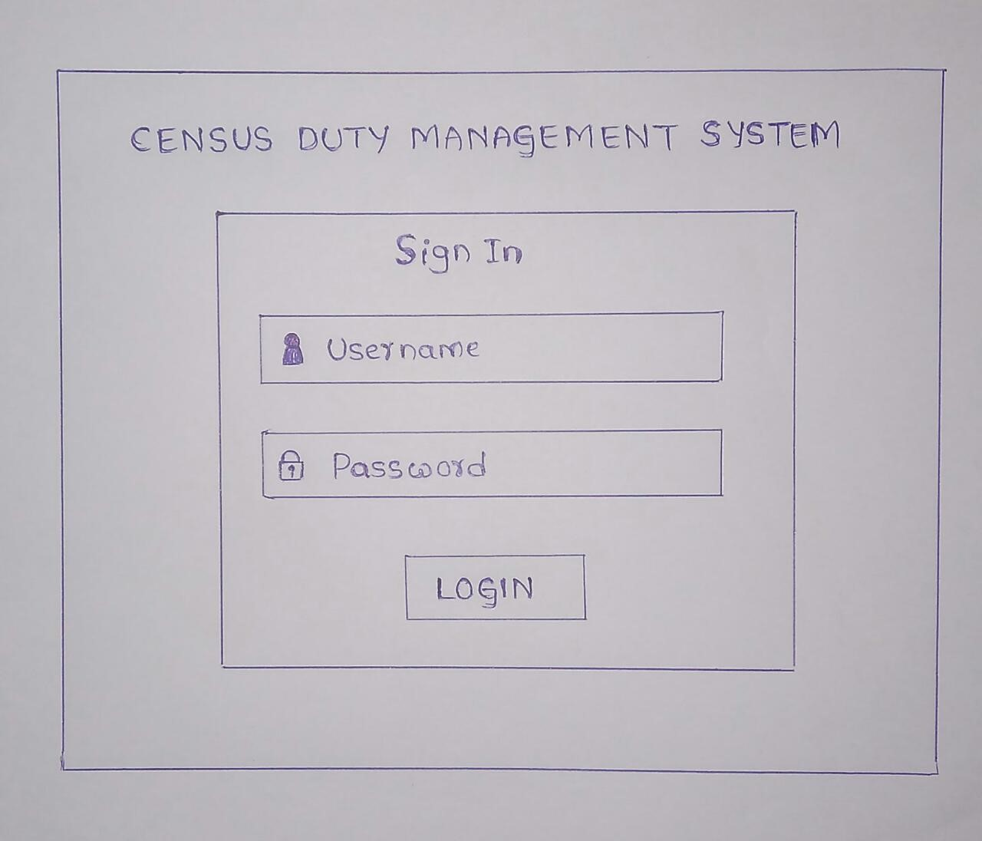

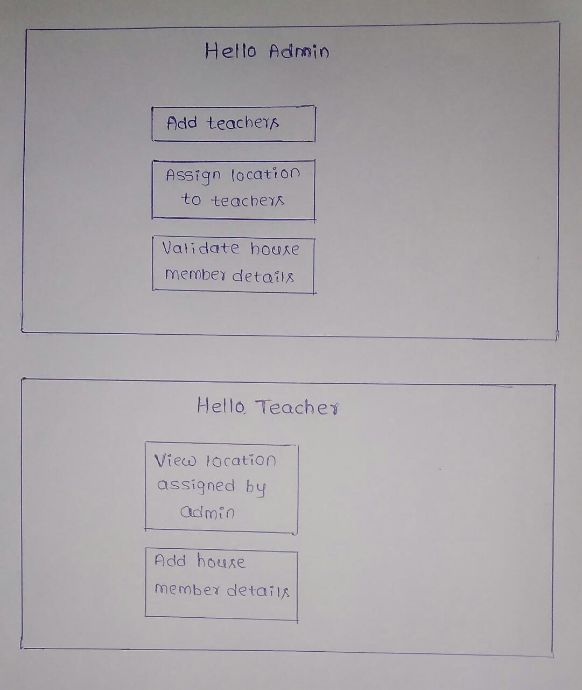

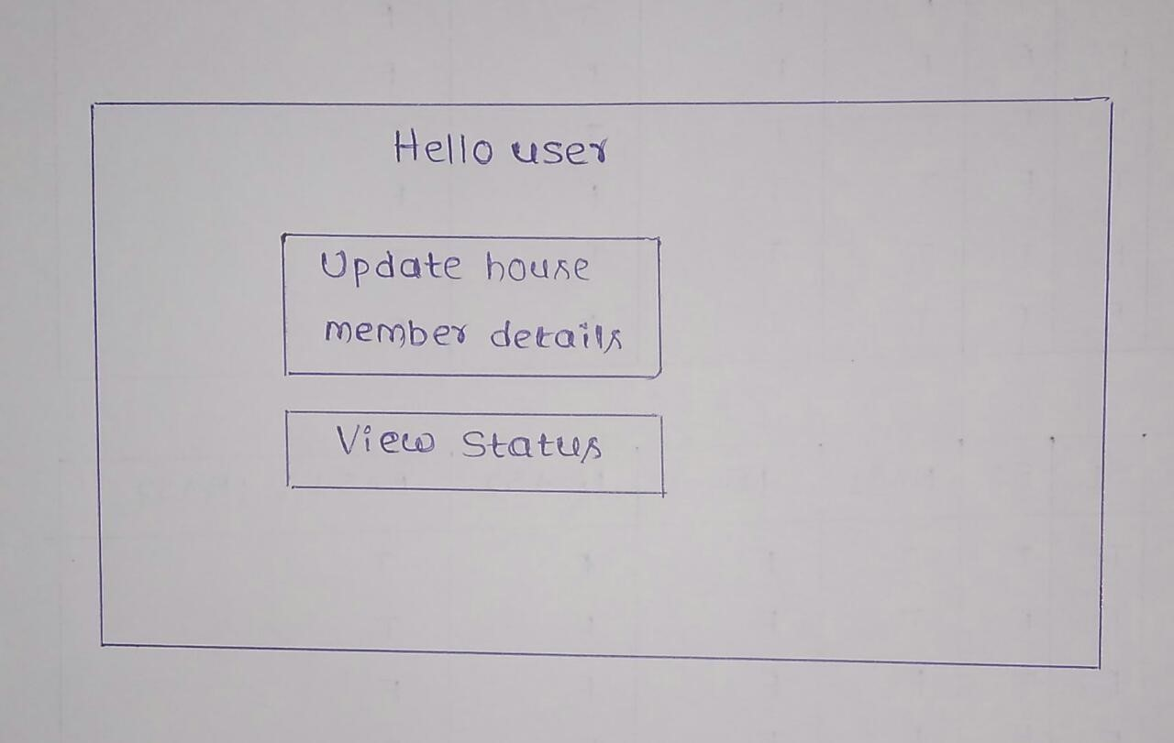

**Class Diagram:**

1. Login
2. Admin
3. Teacher
4. User
5. Add Details
6. Update Details
7. Location

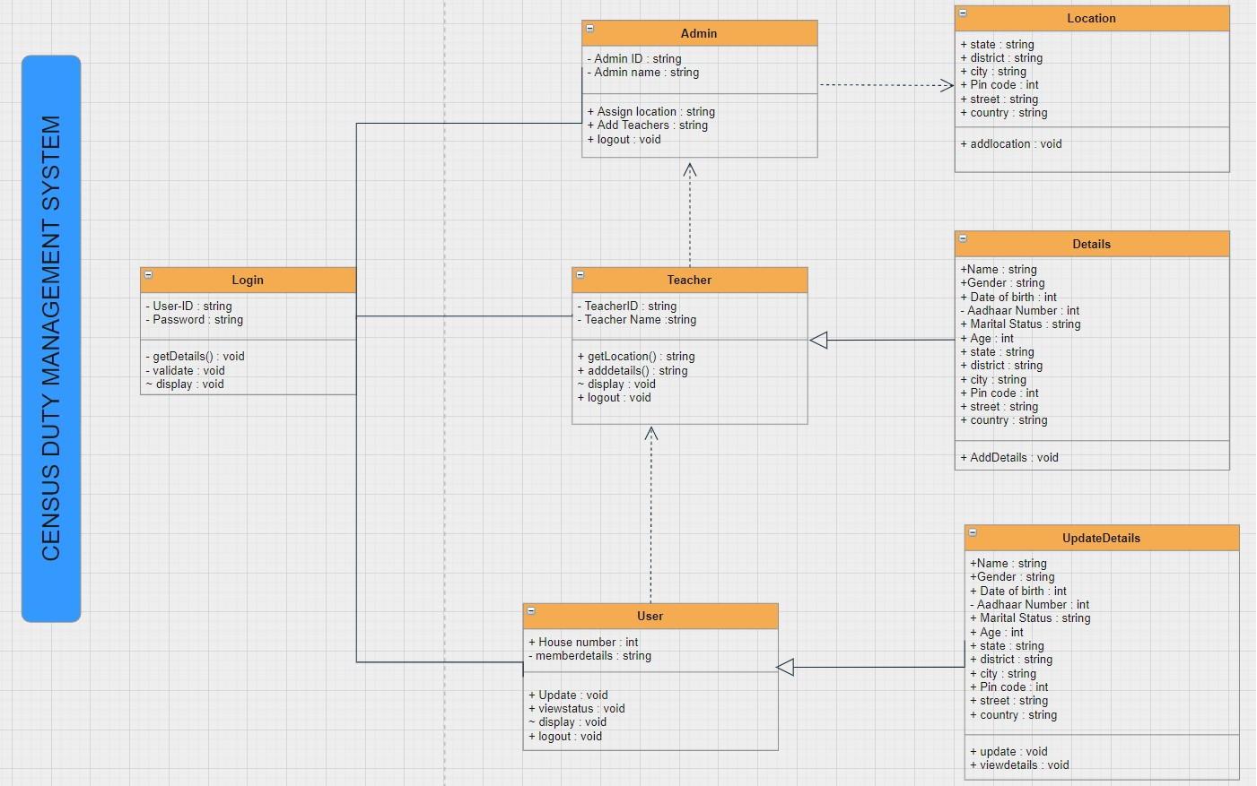

**Modifications done :**

1.Completed JDBC Connection.

2.Fixed some errors.

3.Implemented JTable.

4.Modified UI Design.

5.Fixed login page issues.

*********